Home Care Aide
Training Manual
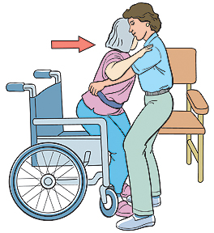

Lifting & Moving Clients:
Simple Ways to Protect your Back
Home Care Aide Orientation

Table of Contents
Moving Clients with Care 4
Reduce your Risk of Back Pain 4
Understanding Your Back 5
How to Use Assistive Devices 6
Draw-Sheets 6
Trapezes 6
Transfer Belts (Gait Belt) 6
Mechanical Lifts 7
Moving Clients with Special Needs 7
Moving Clients in Bed 8
Moving Clients To and From a Wheelchair 9
If a Client Falls 11
Self-Care: A Daily Dose of Prevention 12

Moving Clients with Care

As a home care aide, you may be assigned clients that require assistance with lifting and moving. Some situations no matter how strong you are or what technique you use, may be difficult. Not only do you carry a heavy load; you also have concerns about your client’s safety. With this module you can learn simple ways to ensure the clients safety and yours as well. Using the right moves and techniques, you can protect your back throughout each day.

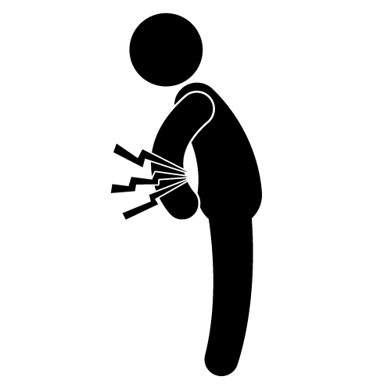
BACK PAIN: A Common Complaint

Back pain is very commonly heard of among healthcare workers who move and transfer patients or clients. But back pain doesn't have to be unavoidable side effect of your job. The problem really starts with improper lifting and moving, which often leads to unnecessary stress on you back, injury, and chronic pain. Once you’ve injured your back, re-injury is much more likely.

Reduce your Risk of Back Pain
Transferring clients may be somewhat of an athletic activity, but big biceps aren’t the key to safe lifting. Protecting your back depends on working smarter, not harder. When you learn to move safely and efficiently, you reduce your risk of back pain and improve client care at the same time.

Understanding Your Back

Understanding your back anatomy helps you keep your three natural curves balanced so you can move safely and efficiently. Maintaining the balance throughout the day may feel as challenging as walking on a tightrope.

Balanced Spine: A spine is made of bones (vertebrae) and pads of cartilage (disks) arranged in 3 natural curves; your neck (cervical), your middle back (thoracic), and you lower back (lumbar curve).
Strong, Flexile Muscles: Strong, flexible muscles keep your 3 natural curves in their normal, balanced alignment. Strong abdominal and back muscles can act like a brace to support your lower back.

☺ Good Posture keeps you spine and muscles balanced, protecting your disks, nerves and the rest of your spine from injury.

Bad Posture destroys the balance of your spine and muscles, allowing injury to you muscles, disks and nerves.

How to Use Assistive Devices

A variety of assistive devices can make your job a little easier, and help your client. They are especially helpful when lifting or moving clients who have difficulty moving at all. Assistive devices can reduce friction, help the patient assist you, and provide you with a handhold – all of which reduce the stress on your back.

Draw-Sheets

Draw-sheets allow you to move clients easily in their bed. Made of sturdy, heavy cotton, these sheets also protect the client’s skin by reducing friction. When using a draw-sheet, make sure the client is supported from shoulder to thigh. Tip: Don't have a draw-sheet? A top sheet from any sheet set, folded a few times so it fits properly, works perfect! Just keep it free of wrinkles!

Trapezes
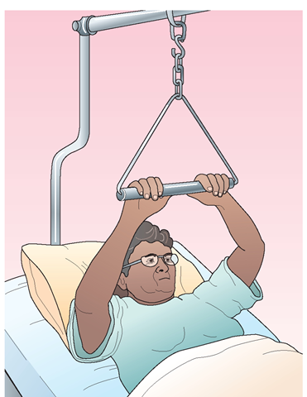

A trapeze allows clients to assist moves in bed. The metal triangle, suspended from an overhead bedframe and connected to a post, is attached to the bed. Adjusting the length of the chain, so the clients’ elbows are slightly bent when grasping the trapeze, helps them lift more easily.

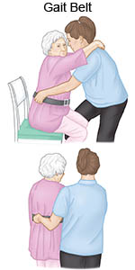

Transfer Belts (Gait Belt)

When moving clients, it’s a good idea to use a transfer belt, or gait belt. Transfer belts fit snugly around the client’s waist to help provide you with a handhold. Hands should be placed under the belt, on the sides, more towards the back when assisting with standing or transferring. When walking, one hand should be placed under the belt, at the center
of the client’s back to provide assistance if needed.

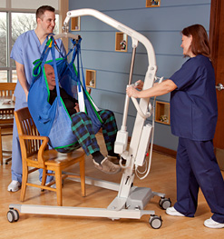
Mechanical Lifts

If clients need the maximum assistance needed when transferring, you may need to use a mechanical lift to move them. The hydraulic pump lift OR electrical lift raises the client as they sit in a sturdy sling. Be sure to read the operating instructions carefully and get to know the lift you’re using before you use it.

Moving Clients with Special Needs

You might assist with transferring clients with special needs everyday you’re in their home. These moves require more forethought than usual and are often a little more difficult because the client has even less control, or the ability to help. In most cases, you will need extra help or the help of assistive devices.

- Frail or Weak: With frail, fragile, or weak clients, take your time planning and talking through your transfers. This will ease the client’s anxiety and help you use smoother, more controlled movements. Remember to give the client time to rest.

- Overweight: Because they are heavier, overweight clients are more difficult to move in bed. Their extra weight also puts you at a greater risk for injury. Have the client help as much as possible with turning, lifting and standing.

- Paralyzed: If the client is partially paralyzed, (paralyzed from the waist down - paraplegic, or on one side of the body – hemiplegic, have them assist you as much as possible. A paralyzed client may not be able to help at all so a draw sheet would be needed for turning in bed. Move one body part at a time to limit stress on your back and use any assistive devices they have to help with transfers.

- Tubes: Moving clients with tubing should be done very cautiously. If the client has a feeding tube or urinary catheter be careful not to pull on them or get them tangled during movement. Always have an eye on the tubing to ensure the client isn’t laying on them or they are not being pulled taut.

Moving Clients in Bed

If you know the right techniques, moving clients in bed can be safe and simple. Although these moves are less complicated as some, don't overlook the risk involved. If you move clients in bed several times a day, you often may try to do it alone or too quickly. This can increase your risk of back injury, especially if you do not use good body mechanics. Be sure to take your time and ask for help if you need it.

- Pulling a Client Up in Bed
Think of ways you can decrease friction to make this move more comfortable for the client and reduce the strain on your back. Two people using a draw-sheet can slide a client up in bed more easily. Clients can also bend their knees, push down with their feet, and pull up with a trapeze, a device we talked about earlier.
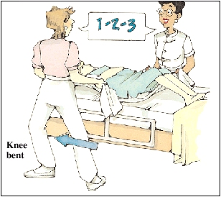

1) Put the head of the bed in a flat position and adjust the height of the bed to waist-level if possible. Grab the draw-sheet with your palms facing up, bending your elbows as shown.
2) Point one foot towards the direction of the movement and lean in the direction of the move. On the count of 3, lift and pull the client up. Repeat if needed.

- Turning the Client in Bed
It is difficult to get close enough to clients in bed to turn them over safely, so concentrate on putting your body as close to theirs as you can. This will help balance you 3 natural curves and keep the stress on your back to a minimum. This is a one or two person task. The client can sometimes help by reaching for a handrail, if there is one present, or pushing down with a heel to help push themselves over to one side. Start the turn with the client on the side of the bed opposite of where they will be rolling.

1) If you can, adjust the bed to hip level. Have the client cross their arms or have them reach for a handrail on the side of the bed to which they are turning. Have the client bed their knee; if they are turning to the right, have them bend their left knee, if they rolling to the left, have them bend their right knee.
2) Grasp the draw-sheet, bend at the knees and use the muscles in your legs to roll the client to one side of the bed. Always roll them towards you, especially if there are no handrails present. This will protect them from rolling off of the bed and provides security.

Moving Clients To and From a Wheelchair

Assisting a client from their bed to a wheelchair or to a standing position requires their help! Clear communication is essential! Explain to your clients the steps of what you are about to do, tell them they can rest whenever they need to, and ask them if they are ready to move. It’s important to ask how much they can help. You might have to use a transfer belt to provide assistance when moving.

To begin… Assess the client in your care:
- Find out about the person’s strength and mobility.
- Know your employer’s lifting policy and follow it.
- Let the client do as much as they can for themselves. This will not only increase their strength and control, but it will also be much safer for your and your back.
- Be aware of things like weak limbs, confusion, aggressive behavior, or lack of motivation.

Prepare the environment:
- Don’t make things harder than they have to be. Adjust the bed, chair, or other equipment to make the positioning or transfer as easy as possible.
- Remove any clutter on the floor, and make sure medical equipment such as oxygen tubing and other lines won’t become tangled during the positioning or transfer.
- Lock the brakes on the wheelchair and remove obstacles from your path before beginning the transfer.
- Apply transfer belt if one is available.

Communicate:
- Tell your client what you are going to do before you do it. Talk through everything you are doing so that the person in your care knows what to expect
- Whatever the client can do for themselves, let them do it. Be there to provide support, instruction, and encouragement.

Whether you are assisting your client from the bed to a wheelchair, chair to toilet, or chair to shower chair, the concepts of safe transfer techniques remain the same.

1. Have the client sit towards the edge of the bed. If the bed does move, make sure it is level or slightly above the wheelchair seat height. Brakes on the wheelchair are locked!
2. Check their orientation. Ask them if they are feeling dizzy from sitting up. If they sit up too fast it may cause a change in blood pressure and they could become a bit disoriented. Have them gain their composure before continuing.
3. Explain to them everything you are doing and tell them how they can help. This prepares you and them for the transfer. This will also get them ready to help! You can instruct them to “stand up on the count of 3” or “reach for the chair arm”.
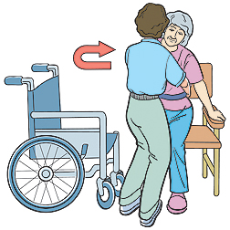
4. Get in position. Face what you are lifting. Instruct the client to push up with their hands as they begin to stand or have them place their hands on your shoulders. Do not let the client pull on you, this is only for guidance. Get a good base of support by standing with your feet shoulder width apart, one slightly in front of the other.
5. Stand the client up. On the count of 3 ask the client to stand up and assist them by using the gait belt. Hands should be placed on the sides, towards the back of the belt.
6. Pivot towards the chair. Have the client turn towards the chair and begin to sit down once they feel the chair behind them. As they sit down, bend at the knees and guide them down without bending at the waist.

Always Remember:
- If a client is weak, brace your knees against their knees to keep their legs from buckling.
- If in a bathroom, utilize any handrails available. Do not have them pull on towel racks! These typically are not sturdy and can pull out of the wall easily, injuring your client.
- After a bath, wet clients are slippery. It’s safer to dry them before trying to move them!

If a Client Falls
When a client begins to fall your first instinct may be to catch them – a difficult and dangerous thing to do. Once the momentum has started it is almost impossible to stop the fall. Trying to do so may severally injure your back. Instead you need to guide the fall and help get your client to a safe place, minimizing injury, if not avoiding it all together.
Guide the fall: Help falling clients to the floor with as little impact as possible. If the client is wearing a gait belt, grasp the belt on each side, get a firm wide stance, and slow the fall down by guiding them to the ground. Focus on protecting their bottom from hitting the floor hard, which could cause a hip or vertebral break/fracture. Focus on protecting their head from hitting the ground, close objects, or the wall.
If your client does fall, do not try to pick them up!
- Look for injuries that would make them getting up unsafe, like possible broken bones or bleeding.
- Have the client get up in steps when they are ready to do so.

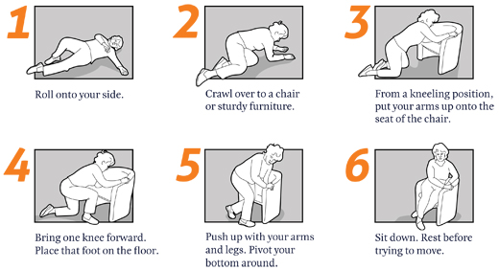
If a client falls, follow these steps:
- Look for injuries such as: bleeding, obvious breaks, dislocations, mental confusion, etc.
- Call for help immediately. Do you call 911?
- Notify the supervisor as soon as possible. The physician should be notified as soon as possible, as well.
- Document very carefully. Make careful observations about the client’s condition and the surrounding area.

Self-Care: A Daily Dose of Prevention
You can use self-care and the right lifting and moving techniques to keep your back healthy and help prevent injuries. Back exercises build strength and muscle flexibility. Relaxation techniques can help reduce stress, which often aggravates back problems.
Even just a few minutes of daily back exercises can help prevent back injuries. They strengthen and stretch muscles that support your back and warm up your body for strenuous activities.

