Home Care Aide
Training Manual
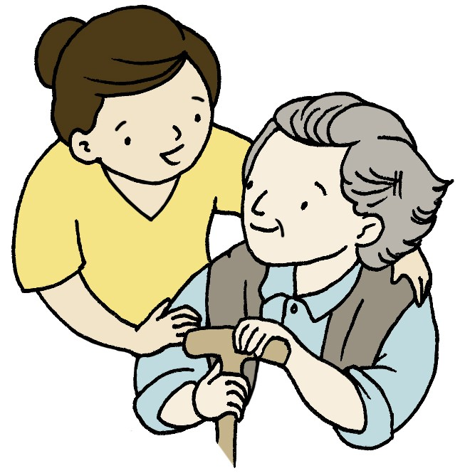

Helping with Activities of Daily
Living & IADL’s
Home Care Aide Annual Training

Table of Contents
What are ADL’s and IADL’s? 4
Examples of ADL’s are listed below: 4
Examples of IADL’s are listed below: 4
Bathing 5
Guidelines for Bathing 5
Oral Hygiene & Denture Care 6
Tools needed for oral hygiene include: 6
The Basics for Brushing Teeth 6
The Basics of Denture Care 7
Toileting Tasks 8
Dressing and Grooming 9
Helping Clients Eat 10
How and What to Document for ADL’s 11
Independent Activities of Daily Living (IADL’s) 12
Helping Out with the Telephone 12
How You Can Help 12
Shopping for Clients 13
Planning and Preparing Meals 14
Encourage Independence: 15
Helping Out with Housekeeping 15
Staying Safe During Transportation 16
Assisting with Self-Administered Medication 17
Summary 18

What are ADL’s and IADL’s?
ADL’s or activities of daily living are basic self-care needs that everyone has and can normally do for themselves if they are without illness or injury.

Examples of ADL’s are listed below:
Bathing &Personal Hygiene – Bathing, showering, hair washing and oral care.
Bowel & Bladder Control/Toilet Hygiene – Recognizing the need to go to the toilet, getting to the bathroom or commode, cleaning as necessary.
Dressing & Grooming – Putting on and removing clothes, brushing hair, shaving, applying make-up.
Eating – Preparing food, using utensils, chewing and swallowing.
Functional Mobility – Getting around the home to carry out activities, transfers or walking while preforming activities.
IADL’s or instrumental activities of daily living are activities that go beyond basic needs. IADL’s allow a person to be independent at home and in the community.

Examples of IADL’s are listed below:
Housework - Keeping the environment clean and safe to live in, including laundry and doing dishes.
Meal Preparation – Planning and preparing meals and snacks.
Taking Medications as Prescribed - Understanding what medications are prescribed, why they are needed, how to take them and possible side effects.
Shopping – Navigating around a store, finding items and making purchases.
Using the Telephone – Locating and dialing numbers, carrying a conversation with the person called.
Transportation within the Community – Driving, asking a friend or family member to drive or using public transportation to get around.
.

Bathing
The purpose of bathing is to remove perspiration, dead skin, excess oils and bacteria from the body. It also increases circulation, is refreshing and is relaxing. The frequency with which an individual bathes is a personal choice. While some bathe daily, others may only bathe once or twice a week. There are different ways to bathe based on an individual’s choice and/or on their abilities/disabilities. Bathing options include:
- Tub bath wherein individuals bathe in a bathtub. They may or may not require assistance getting in and out.
- A shower wherein individuals can stand in a shower, sit on a bath bench in a shower, or have a special shower chair wheeled into the shower (if it is designed for easy access).
- A sink wash wherein individuals either stand at the sink and wash or they sit on a chair/wheelchair in front of the sink.
- A bed bath wherein individuals have their entire body washed while in bed. It is utilized for people who are not capable of bathing themselves.

Guidelines for Bathing
- Prevent or reduce drafts
- Ensure privacy
- Protect individual from falling
- Use good body mechanics
- Wash from the cleanest area to the dirtiest area
- Ensure the temperature of the water is comfortable
- Keep soap in dish when not lathering
- Encourage individual to help as much as possible
- Dry skin well
- Take safety precautions:
  - ensure bottom of tub and/or shower are “gripped” (e.g. a bath mat or nonskid strips)
  - use grab bars for support
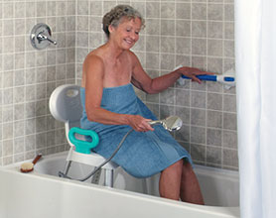
  - place personal care products within individual’s reach; drain the bathtub before the individual gets out
  - don’t run water while an individual is bathing (e.g. dishwasher, washing machine, toilet or sink)

Oral Hygiene & Denture Care
The purpose of maintaining good oral hygiene is to:
- Keep the mouth and teeth clean, as this will help prevent bad breath and infections
- Enhance the well being of the individual
- Make food taste better
- Reduce tooth cavities
- Help prevent periodontal disease

Most individuals look after their own oral hygiene but, sometimes assistance is needed to either gather up the required tools, which will enable the clients to do their own mouth care or the Home Care Aide may have to perform mouth care for them.

Tools needed for oral hygiene include:
- Toothbrush
- Tooth paste (or denture paste for false teeth)
- Dental floss
- Mouth wash

The Basics for Brushing Teeth
- Teeth should be brushed 2-3 times a day – usually after breakfast, lunch and supper or at bedtime. The recommended duration is 2-3 minutes. At the least, brush the teeth in the morning and at bedtime.
- A toothbrush is not meant to be shared, as this could spread germs.
- The ideal brushing technique should focus on brushing along the gum line, which is the point where the teeth meet the gums. This is the breeding ground for tartar and bacteria.
- Clean every surface of the tooth ensuring all chewing surfaces are brushed

The Basics of Denture Care
Having dentures is like having real teeth. Regular cleaning and maintenance are as necessary for dentures as they are for regular teeth. Because dentures tend to accumulate bacteria, conditions could surface, which may result in additional tooth loss, swollen and bleeding gums and infections.
- Use a denture cleaner at least twice per day like a normal brushing routine. A good rule of thumb is to brush, then soak, and then brush them again. Be careful about dropping the dentures while they are being cleaned as they may chip or crack. By placing them over a towel or over a sink full of water, unfortunate accidents may be prevented.
- By soaking the dentures in a special denture cleaner, the cleaning process can be speeded up. As they are scrubbed and wiped dry, use light circular motions to avoid scratching or grooving the surface. Though all surfaces must be thoroughly cleaned, the key area is where the denture comes in contact with the gums. This is really important especially if the client uses an adhesive.
- In the event that serious stain builds up or tartar develops, they can be taken to the dentist for a professional cleaning.

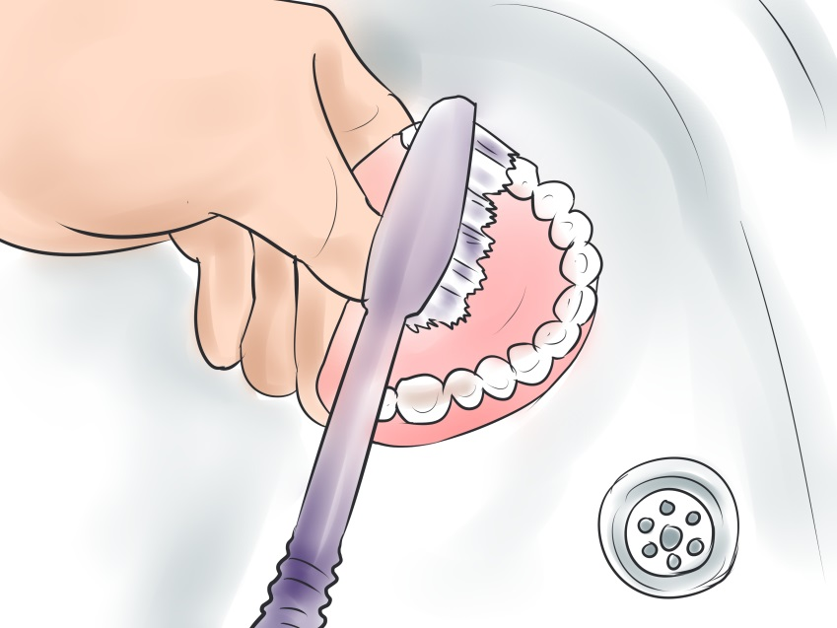

Toileting Tasks
There is no way around this activity. Every client has to eliminate and depending on their capabilities, toileting might involve:
- Toilets are used in all homes.
If your client can use the toilet be sure they have a safe path to get to the bathroom.
- Bed pans are generally used by people who are immobile and cannot get t o a toilet.
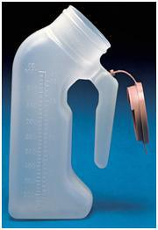
If your client uses a bed pan, have them roll to one side while you place the pan underneath their buttocks. Protect the bed by having a waterproof pad underneath the bed pan in case contents spill out of the pan. Your client will still need privacy so elevate the head of the bed if you can, cover their lap with their gown or small sheet, and step out of sight.
- Urinals are used for men that have a hard time getting to the toilet or they are immobile.
If your client uses a urinal, have them sit on the side if the bed to use it if possible.
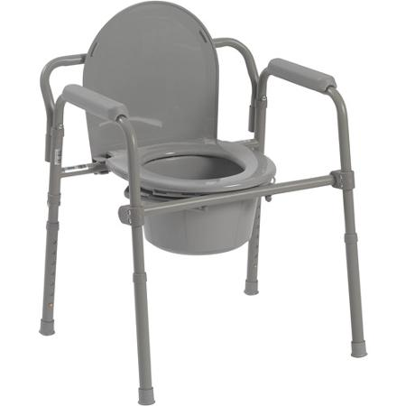
- Commodes are chair-like, mobile toilets on wheels or they can be stationary. They are used at the bedside or at a more private location.
If your client uses a bed-side commode, make sure they are placed safely on the commode and give them privacy for elimination. Once they are finished they made need assistance with cleaning. Always wear gloves when handling soiled material and dispose of the contents properly. Do not let urine or feces sit in a bed-side commode. Clean it out immediately.
- Disposable garment protectors or adult briefs are padded undergarments that will hold elimination and must be changed frequently if soiled. They are used for clients who have difficulty holding urine or are completely incontinent, unable to withhold urine or a bowel movement.
If your client wears briefs be sure they are changes at least every 2 hours if soiled. Sitting in a soiled brief for any amount of time could cause skin irritation and breakdown. It’s important to help them stay clean.

For all Clients…
Always provide privacy during elimination. If your client requires supervision, stand just out of sight. If there is a fear of them falling in the bathroom, do not leave them unattended. Avoid hovering or standing in the bathroom close to your client while they are trying to use the bathroom. This is uncomfortable and may prevent elimination. Some clients may have a hard time with cleaning after elimination. If you are to assist with cleaning, make sure you wear gloves and assist as needed.

Dressing and Grooming

Good grooming habits are very important to some people, while others do not give them the same value.
- To the first group, it is tied into their body image and self esteem. Men in this category will feel better, if they are clean-shaven or if their beards and mustaches are trimmed. Women are concerned how their hair, nails and clothing look and are perceived.

- The second group “goes with the flow”, so to speak, and are not overly concerned about how they look. They adopt the “take me as I am” attitude. When dealing with clients, the caregiver usually adapts to the clients’ standards. Note: Sometimes, if grooming habits are poor, suggestions might be made to clients about how they might improve their appearance and what the benefits would be; however, they need to be receptive and must not be forced or shamed into changing their habits.

Getting dressed and taking care of your appearance may sound easy but for clients with physical disabilities or mental impairments, dressing and grooming tasks are often difficult to manage alone.
You can help your clients feel good about their appearance by:
- Helping clients choose clothing: Clients should be allowed to choose their own clothing if able. Letting clients choose their own clothing gives them a sense of independence and control.
- Laying out their clothing: Clients with dementia may have trouble making choices. In this case, you might want to limit their choices to 2 items or choose the clothing and lay it out for them.
- Assisting with dressing: Clients with physical impairments, like paralysis after a stroke or stiff joints from arthritis may need you to assist them with dressing. Best choices are items with elastic waistbands and no buttons or zippers.

Helping Clients Eat
Eating may be difficult for the clients you care for. They may have trouble chewing or swallowing due to a physical disability, like a stroke. They could also feel nauseated by certain medications or have little to no appetite. What ever the reason is, it’s your job to help your clients get the nourishment they need to stay physically healthy.

Just like all ADLs, there are varying levels of support needed. Follow your clients are plan for preparing and serving foods. Below are general guidelines to follow:
- Sit for Safety! Position your clients so they are sitting as straight up as possible. Feeding a client who is reclining increase their risk for choking.
- Prepare and Present! Open any containers or packets that might be hard for the client to do themselves. Make sure warm food is served warm and cold food is severed cold and seasoned the way they like if they cannot season it themselves. If your client has a hard tome chewing, cut solid foods in small pieces.
- Take it Step-By-Step. For client who can feed themselves, but may become confused, give simple step-by-step instructions. It's important to remain patient and kind, even if you feel the client is being difficult.
- Take Time to Socialize. For many people, mealtimes are about spending time with family and friends. Sit down with your client during meal time and talk them.
Always encourage your clients to do as much as they can for themselves. For clients who cannot feed themselves, here are a few best practices:
- Fill a spoon half full and feed the client with the tip of the spoon. Do not use a fork.
- Place the food on the center of the tongue, using slight downward pressure.
- Allow your client to chew and swallow each bite.
- Vary the foods you offer. For example, alternate between mashed potatoes and meatloaf so they do not fill up on one or the other.

How and What to Document for ADL’s

When documenting ADL’s, two pieces of information are important – what happened and how much you helped.
What happened? You must document what the client actually did, not what they might have done or may be capable of doing, even if it varies from day to day. Below are some examples of how to document how your client performed the ADL:
- Independent – The client preformed the ADL with no help or supervision from you.
- Needed Supervision – You provided oversight, encouragement, or cueing during the activity.
- Limited Assistance – The client was highly involved in the activity but required physical help to move limbs.
- Extensive Assistance – The client preformed part of the activity, but needed weight-bearing support.
- Total Dependence – The client was unable to preform the activity, total assistance was needed.
How much did you help? You will need to document exactly how much you helped. Some options are:
- No setup or physical help needed from caregiver – The client completed the activity with no help from you.
- Setup help only – You set the materials and the client preformed the ADL independently.
- One person physical assist – You physically assisted the client to complete the ADL.
- Two person physical assist – You and another person/co-worker physically assisted the client.
Eating has a separate language. You may be asked to record your clients meal intake, record their appetite, or how the food was eaten. Here are a few ways to document that:
- Refused to eat or 0% was eaten.
- Poor appetite, less than half eaten, or 25%
- Fair appetite, half was eaten, or 50%
- Good appetite, more than half was eaten, or 75%
- Excellent appetite, all of the food was eaten, or 100%

Independent Activities of Daily Living (IADL’s)

Helping Out with the Telephone
Using the telephone is an important part of communication. Phone communication is needed for setting appointments, getting information, calling for help, and socializing. Losing the ability to use the phone can be frustrating, isolating and dangerous.

There are several things that can happen, especially as people age that can make using the phone difficult, including:
- Hearing loss
- vision loss
- confusion
- Immobility

How You Can Help
Hearing Aides – Encourage clients to wear their hearing aides or talk to their doctor if they are having a hard time hearing. Seniors who have a hard time hearing greatly benefit from using a hearing aide. If your client uses hearing aides make sure they are in and on. Also make sure the battery is working and help your client replace them as necessary.

Change the Telephone – Some telephone shave volume dial and some are made with different frequency responses. For some clients, turning the volume up can make hearing more difficult. Large numbers and buttons on the telephone help someone with low vision see the numbers and dial easier.

Rewrite the Phone Book – If searching for numbers in the phone book is difficult for your client, rewrite most frequently used numbers in a larger font so it is easier for them to see.
Get High Tech with a Cell Phone! Don’t assume seniors are “too old” to use cell phones or learn how to use them. If your client has a cell phone, take time to teach them how to use it. Some cell phones are specifically designed for seniors and allows them to text easily too.

Shopping for Clients
If it’s in your service plan to shop for clients, you will probably be asked to go, or assist your client to the store or pharmacy.
When shopping duties involve going to several stores in a single trip, always do the food shopping last. That way food that needs to be refrigerated immediately doesn't spoil in a hot car. Before you go shopping, take a list. Shopping without a list leads to buying unnecessary item and forgetting things that may be needed.

- If you are also responsible for planning and cooking meals, you may want to prepare a weekly or monthly meal plan first, then create a grocery list from that plan. Always involve your clients!
- Each week, post an ongoing shopping list on a board or their refrigerator to remind family member s or other caregivers what your client needs or what they have run out of.

Before you go shopping, you need to know if there is a food budget. Chances are your client has a limited budget for food. That means you have be aware of saving money and stretching meals.
Here are some money-saving tips to use while shopping for clients:
- Clip coupons and check out the weekly grocery store ads for sales and deals. A few dollars per week adds up to real savings over the course of a year.
- Buy store brands whenever possible. They are usually just as good as major brands but cost a lot less.
- Purchase fresh fruits and vegetables when they are in season. If your client can get out of the house a trip to the local farmers market is a great way to save money and produce and get some exercise.
- Combine trips to save gas. Try to time your grocery store visits with other trips needing to be made, like to the bank or pharmacy.

Planning and Preparing Meals
If it is your job to prepare food for your client, start with a meal plan. You may want to plan for a week or 2 weeks if you can. There are a few considerations to take into account before you start your meal planning. You will need to know:
- Is your client on a special diet? Special diets, like low sodium, low fat, or diabetic diets are directed by the doctor or nutritionist. It’s important to now the specific guideline for the diet they are on.
- What are you client’s favorite foods? You can ask clients or their family about favorite foods or food related to cultural purposes.
Quick tips you can use with all clients:
- Meal plan choosing foods from every category: grains, proteins, vegetables, fruits, and healthy fats.
- Eat whole grains such whole grain bread, pasta, and brown rice.
- Limit white potatoes and refined grain products such as white breads and white pasta to small side dishes.
- Limit concentrated sweets to occasional treats.
- Eat a healthful type of protein at most meals, such as beans, fish, or skinless chicken.
- Choose fresh or frozen vegetables. Cook just until tender to preserve the nutrients.
- Serve fresh fruit everyday such as apples, bananas, grapes, oranges and grape fruits. Clients are more incline to eat them if they are cut up and prepared as a snack.
- Have three meals and one or two snacks each day, and don’t skip breakfast.
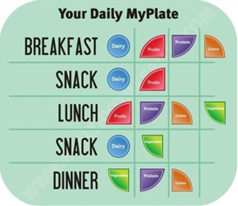
Having trouble planning meals? Use ChooseMyPlate.gov as a map for planning meals throughout the day!

Encourage Independence:
Meal preparation is a basic life skill that can help people functioning independently in their homes. Encourage your clients to participate in meal preparation as much as possible.
- If your client has a difficulty standing for a long period of time, have them sit at the table to chop vegetables or prepare food.
- Allow them to choose what foods they want to put together for a meals. by giving them a few options of what is available to prepare.

Helping Out with Housekeeping
Helping out with housekeeping duties is important in maintaining a healthy and safe home for your client and improving their quality of life. Housekeeping duties differ from home to home for a variety of reasons but the basics remain the same.
First, take a look at what your client has for cleaning supplies. The basics would include:

- Broom and dust pan
- Mop and floor cleaner
- Vacuum
- Sponges
- Dusting cloths
- Disinfectant cleaner
- Rubber gloves
- Bleach
- Disposable wipes
- Paper towels
Here are some guidelines for assisting clients with housekeeping:
- First, understand that housekeeping is important to help clients live in a safe and healthy environment.
- “Clean” doesn't have to smell like cleaning products. Be aware that some fumes might be irritating and harmful to your client.
- Never mix cleaning products. This can cause harmful chemical reactions that could be very harmful, even fatal.
- Read the instructions and ingredients in all of your cleaning supplies.
- Always clean from cleanest to dirtiest, for example, save the bathroom for last and never reuse the same sponge from the bathroom in another room.
- Be prepared to assist your client with the following an a daily basis:
- Clear clutter and put things away.
- Empty the trash daily
- Make the beds
- Hang up towels in the bathroom and rinse the sink out after every use
- Wash dishes after meals
- Wipe down surfaces after meals
- Store or throw away uneaten food
- Sweep/vacuum high traffic areas as needed

Staying Safe During Transportation
If you use your car, or your client’s car, to drive to appointments, shopping, church, or other errands, keeping yourself and your client safe during transportation is very important.

Getting into and out of the car:
- The front seat is probably the best option for most clients. It has a larger door and more leg room than the back seat.
- The front seats in most newer cars are equipped with air bags. It is safe for elderly clients to sit in the front with the air bags but recommended that the seat be pushed back as far5 back as it can go or slightly reclined.

Seatbelts:
- You and your passenger should always wear seatbelts. Make sure they fit both you and your client properly.
Cell phones:
- Never use your cell phone or text while driving. It is illegal and extremely dangerous.

Allow plenty of time:
- Avoid feeling rushed by giving yourself plenty of time to get to appointments. When you feel rushed you are more likely to drive over the speed limit, run through yellow lights, and make unsafe lane changes to pass slower cars.

Drive the speed limit:
- Always drive the speed limit. Driving even over a few miles the speed limit drastically increases your risk of an accident.

Park in places your client can easily get in and out of:
- Your client may have the ability to part in spaces that are closest to the building or store you are at. If they do not, it may be helpful if you drop them off in front of the store so they don't have very far to walk. This would only be an option if it were safe for your client.

Assisting with Self-Administered Medication

As a Home Care Aide you are not allowed to give medications to clients, however, there are still important things about your client’s medications you should know.

Knowing and remembering these five “rights” of medication will help prevent mistakes:
- The Right Client: Always check the label on the medication container to make sure that the client’s name is on it.
- The Right Medication: Check the expiration date and the name of the medication before giving the container to the client. Make sure the medication name on the container matches the name on the service plan.
- The Right Time: Make sure the instructions on the container label for what time or how often to take the medication match the instructions on the service plan.
- The Right Route: Check the label for instructions on how the medication is to be taken. Make sure the instructions on the label match those on the service plan.
- The Right Amount: Make sure the instructions on the container label for how much medication to take match the instructions on the service plan.
Although you may be aware of the medications the client is taking, you may be unable to determine if there will be an interaction between the medications which are being administered and the medications which are taken on a daily basis.
Aside from any obvious legal issues with a non-medical home care aide giving medications, there is always a chance there could be a fatal error made due to lack of professional training.
You cannot give medications but you should…
- Know the medications your client takes and the possible side effects.
- Remind clients to follow the prescribed dosages and schedules.
- Bring the container of medication to the client. Be sure all medication containers are clearly marked with the contents, doctor’s instructions, expiration date, and client’s name.
- Provide food/water to take the medication, as needed.
- Observe the client taking the medication.
- Document that the client took the medication, the time and any other medication or food taken at the same time.
- Report any possible reactions to your supervisor.
- Read the medicine label to your client if necessary.
- Help client to store medications properly. All medications should be stored away from heat and light, as appropriate.

Summary

Home Care Aides often provide personal care to seniors by assisting them with their activities of daily living. These activities include such functions as grooming, bathing, dressing, toileting, transferring and eating. All require a certain degree of knowledge and skills to perform them efficiently and competently. A crucial part of providing support is to encourage clients to participate in their own care as much as possible. This will maximize their functioning ability, enable them to maintain some independence, keep some control over their lives and enhance their self esteem and self validation.

